|  |
| --- |
| Functional test cases -  Invalidation and repayment |
| DMS H7 |

|  |
| --- |
| Test Scenarios – Invalidation and repayment May 2021 |
|  |

# Document version

|  |
| --- |
|  |
| Document version:   |  |  |  |  | | --- | --- | --- | --- | | Version nr. | Dato | Created by | Updates | | 1.0 | 11-05-2021 | Emma Hagerup |  | |

Table of Content

1 Document version 1

2 Introduction 3

2.1 Test data and preconditions 3

2.2 Process flow 3

2.3 Test Scenarios 4

3 Detailed test scenarios 5

3.1 Scenario 1: Invalidation and repayment application rejected based on format validation 5

3.2 Scenario 2: Invalidation and repayment application with notification of rejection based on content validation 5

3.3 Scenario 3: Invalidation and repayment application with notification on decision of manual handling 7

3.4 Scenario 4: Invalidation and repayment application with notification of granted application 8

# Introduction

The purpose of this test is that the economic operator (EO) can send an invalidation and repayment application to an already existing declaration. An invalidation and repayment application is sent by the EO to the DMS ERMIS system. A declarant can apply for an invalidation and repayment after the goods are released and paid for. However, an invalidation application can also be sent for unreleased/released goods which are not yet paid but here we refer to the “Invalidation” test case.

Further, an invalidation and repayment application can be rejected if the declarant does not provide or fulfill the requirements for documentation for the reason of the invalidation and repayment.

## Test data and preconditions

To be able to do the test scenarios the EO has to be able to send a H7 declaration to DMS, and therefore must have had completed test phase one being the connectivity test (See Connectivity Guide document).

The EO must therefore be able to send an invalidation and repayment application with the following services:

* DMS.Import.Declaration.Submit
* DMS.Import.Declaration.Invalidate

To endpoint:

* https://secureftpgatewaytest.skat.dk:6384/exchange/CVR_<CVR>_UID_<UID>

## Process flow

The process flow for an invalidation and repayment application of an already existing declaration can be seen in Figure 1 below.

Figure 1

## Test Scenarios

To complete the functional onboarding phase two, the EO must deliver confirmation of passed test-cases for each test scenarios:

|  |  |  |
| --- | --- | --- |
| **Test no** | **Test Scenario** | **Passed** |
| **1** | Send invalidation and repayment application which is synchronously rejected based on format validation | ☐ |
| **2** | Send invalidation and repayment application which is rejected based on content validation | ☐ |
| **3** | Send invalidation and repayment application and receive notification of decision on manual handling of invalidation and repayment application | ☐ |
| **4** | Send invalidation and repayment application and receive notification of granted invalidation and repayment application. | ☐ |

Figure 2 shows the process flow divided into the above mentioned 4 scenarios.

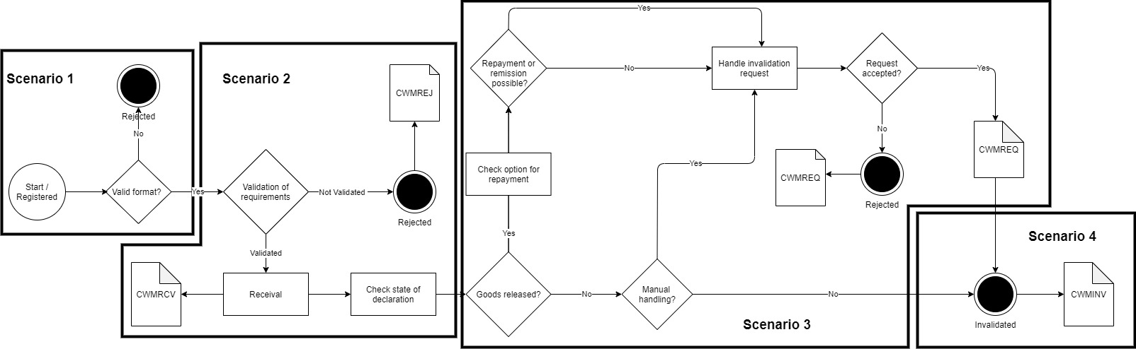

Figure 2

# Detailed test scenarios

The following sections will describe the aim of the specific test scenarios and it will provide the desired results of the test. It should be noted that there can be changes in the notifications provided by the DMS solution, because the solution is still in development. If at a later point more notifications will be added the EO will be informed about this and the EO will be requested to complete the test again.

## Scenario 1: Invalidation and repayment application rejected based on format validation

The following sections will describe the aim of the test and it will provide the relevant test data and results of the test.

The aim of scenario 1 is to test if the EO can send an application for invalidation and repayment and get a synchronous rejection. The rejection is based on a failed syntax validation, so to trigger this an invalidation and repayment application with an erroneous .xml is sent.

**Success**

For this test case to succeed, the invalidation and repayment application should be rejected based on a syntax error. This error will be sent in a synchronous response.

**Test data example**

The following test data should be used:

* Submit initial H7 declaration: *IMA.xml* (remember to fill in LRN)
* Test for wrong format by sending an invalidation and repayment application with wrong syntax in field FunctionCode:

<ns2:FunctionCode>H</ns2:FunctionCode>

* Submit invalidation and repayment application with the syntax error: *InvRep_scenario_1.xml*

## Scenario 2: Invalidation and repayment application with notification of rejection based on content validation

The following sections will describe the aim of the test and it will provide the relevant test data and results of the test.

The aim of scenario 2 is to test if the EO can obtain a notification of rejection based on content validation. In this the EO will obtain a notification of rejection if the invalidation and repayment application does not comply with the content requirements.

**Success**

For the test to succeed, the invalidation and repayment application will be rejected based on content validation. The application will be sent and a rejection notification can be requested and received when validation fails.

A notification has been successfully applied for and received.

**Test data example**

The following test data should be used:

* Submit initial H7 declaration: *IMA.xml* (remember to fill in LRN)
* Test for wrong content by sending invalidation and repayment application with wrong content (non-existing currency) in field AmountDuty/Currency:

<ns2:AmountDuty>

<ns2:Currency>AKK</ns2:Currency  
 …

</ns2:AmountDuty>

* Submit invalidation and repayment application with the validation error: *InvRep_scenario_2.xml*
* Pull notification to see the rejection notification.

## Scenario 3: Invalidation and repayment application with notification on decision of manual handling

The following sections will describe the aim of the test and it will provide the relevant test data and results of the test.

The aim of scenario 3 is to test if the EO can obtain notification that of the decision from the manual handling of the invalidation and repayment application. An invalidation and repayment application will be picked for manual handling if the applicant is not PostNord.

**Success**

A notification has been successfully applied for and received.

**Test data example**

* Submit initial H7 declaration: *IMA.xml* (remember to fill in LRN)
* Fill in the invalidation XML: *InvRep_scenario_3.xml* with preferred LRN and assigned MRN and submit the XML.
* Pull notification to see the notification of manual handling.

## Scenario 4: Invalidation and repayment application with notification of granted application

The following sections will describe the aim of the test and it will provide the relevant test data and results of the test.

The aim of scenario 5 is to test that the EO can obtain notification that the original declaration can be invalidated.

**Success**

For the test to succeed the EO should be able to receive notifications about acceptance of the invalidation and repayment application.

**Test data example**

There is no test data for this scenario.

Since the application is manually handled by a customs officer you should contact you assigned onboarding contact person when the application has been successfully sent:

* Write an email to your onboarding contact person with the following information:
  + Which application was sent (in this case: an invalidation and repayment application)
  + MRN
  + LRN

Your onboarding contact person will then grant the invalidation and repayment application which fulfills Scenario 4.

* Pull notification to see notification of granted invalidation and repayment application.

#Decorative

|  |  |  |  |
| --- | --- | --- | --- |
|  | www.ufst.dk  ISBN |  | Udviklings- og Forenklings- styrelsen er en del af  Skatteforvaltningen |